

Personal Website

Website Design Document

**Student Details: Karen Poudel**

**Term and Year: 2 sem 2023**

**Wentworth Institute of Higher Education**

**Bachelor of Information Technology**

Table of Contents

1. Overview: 3

1.1. Competitive Analysis (Website critique) 3

2. Content and Structure: 4

2.1. Sitemap 4

2.2. Content Inventory 4

2.3. Navigation 4

3. Content Design: 5

3.1. Special effects 5

3.2. Wireframes 5

4. Visual Design: 7

4.1. Color Scheme 7

4.2. Typography 7

# Overview:

## Competitive Analysis (Website critique)



I will also implement the design as above for my index.html page as I like how simple and good this page is.

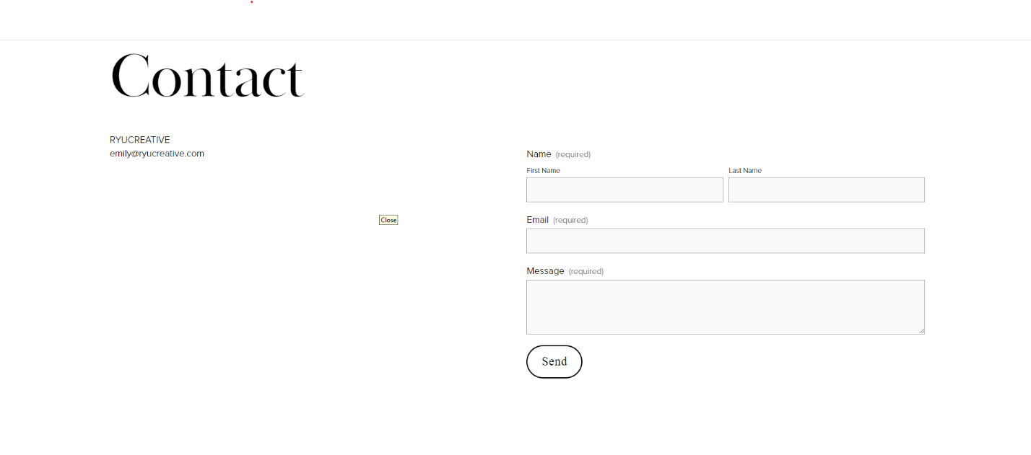

I like the design of contact page I will also create something like this.



I like the hover effect on the navigation bar, I will implement that in my website.

# Content and Structure:

## Sitemap

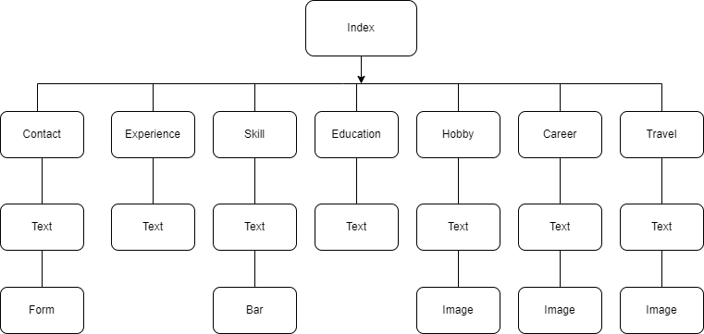

## Content Inventory

Provide detailed content inventory in the following table.

|  |  |  |
| --- | --- | --- |
| Page Name | Content | Type |
| index.html | Introduction and the purpose of the website | Text, images |
| contact.html | Message form is used. | Text, form |
| hobby.html | My hobbies are listed here. | Text, images |
| education.html | My education description | Text |
| experience.html | My experience till now is listed here | Text |
| travel.html | My travel images from Australia | Text, images |
| skills.htm | My skill page | Text, bar |
| career.html | My future career goal | Text, image |

## Navigation

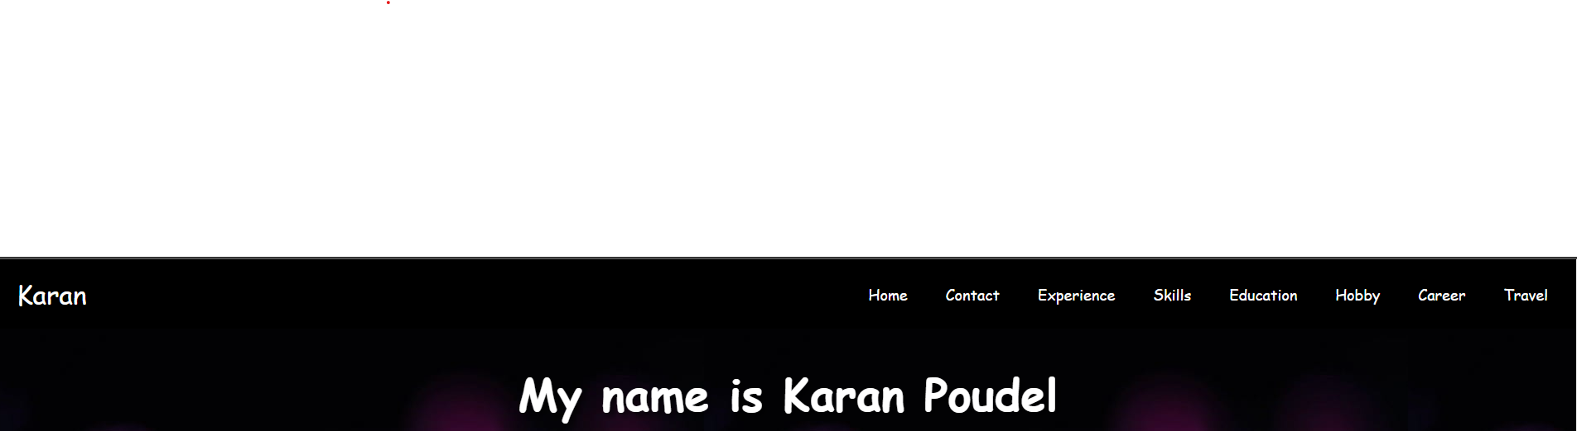

# Content Design:

## Special effects

I have used box shadow which is also CSS3 effect, I have added hover effect in navigation bar. I have also added media to make it responsive and transition is also used.

## Wireframes

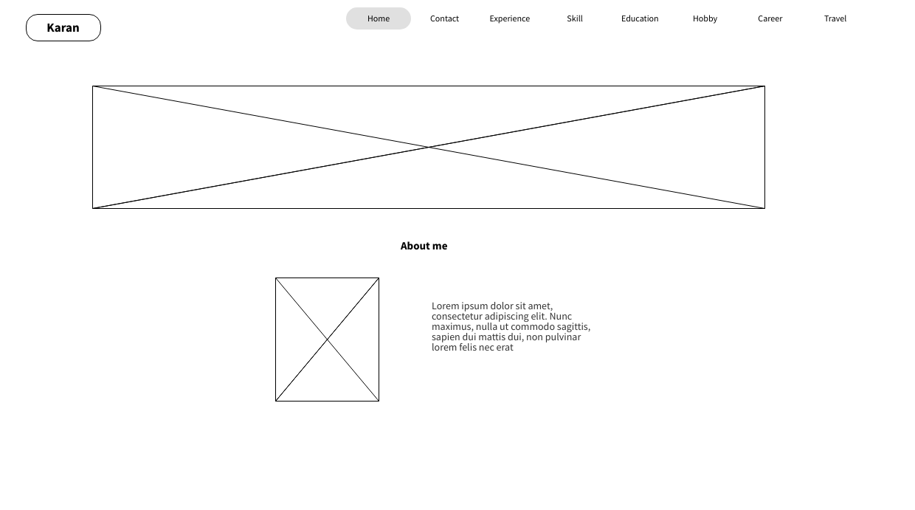

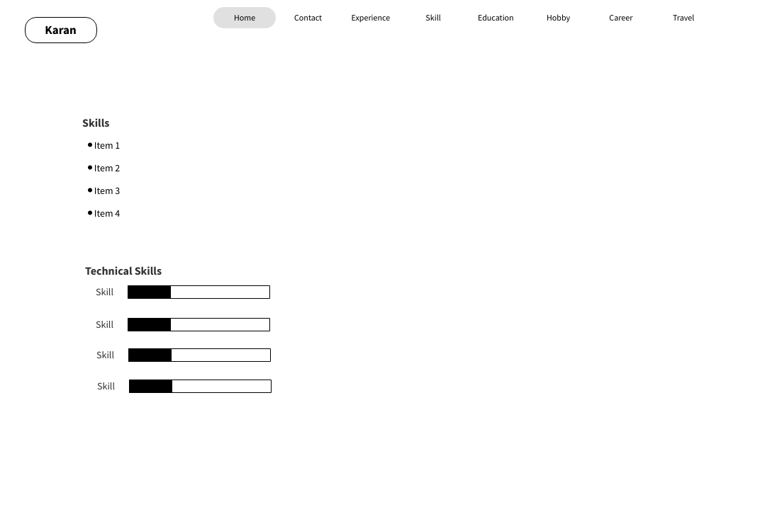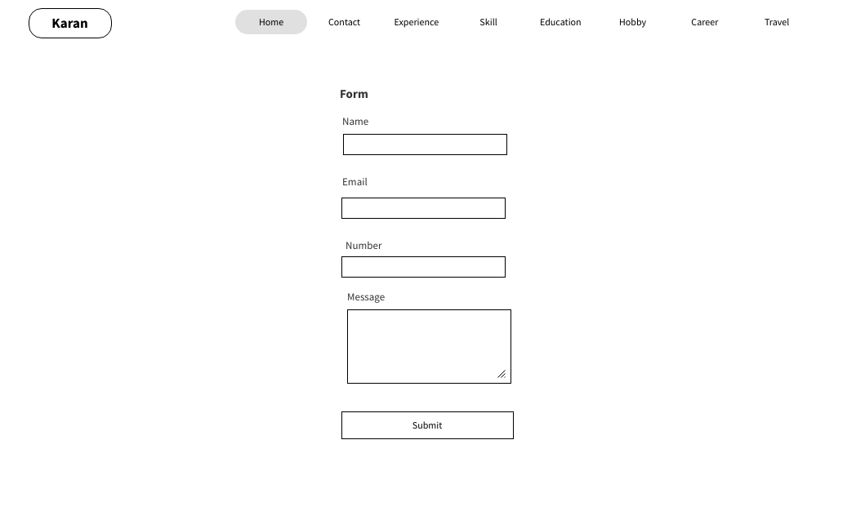

# Visual Design:

## Color Scheme

I have used black, white, grey, dark purple and other color using RGB, basic color to HEX color.

## Typography

I have used cursive, arial and sans-serif based on design I wanted.